# **ECEN 215 – PRIN OF ELECTRICAL ENGR**

# **Spring 2019**

## **Lab 2:Node Voltages and Equivalent Circuits**



**Submitted by:**

|  |  |  |
| --- | --- | --- |
| **Student Name** | UIN: | **Section #** |
| Daniel Lopez | 426001591 | **516** |
| Adam Johnston | 516007336 |
| Jared Blunt | 524009660 |  |

**Date Performed: Feb 25th , 2019**

1. **Objective**

The objective of this lab was to find the node voltages of a given circuit and then use that information to find the values necessary to create a Thevenin equivalent circuit.

1. **Procedure**
2. Calculate the theoretical values of current and voltage for the initial given circuit, by hand.
3. On the breadboard, using resistors and wires build the initial given circuit.
4. Using the multimeter record the values of R1, R2, R3, R4, and RL
5. Using the NI Analog Discovery as the voltage supply, record VS and IL with the multimeter

* Use these values to calculate and record the new values for the circuit

1. Remove RL to measure and record ISC and V0V using the multimeter
2. **Difficulties**
3. Many of the resistors, boards, and other components were damaged or had different values than necessary.
4. The wires were difficult to keep inside the Analog Discovery.
5. **Results**

**Initial Measurements**

|  |  |
| --- | --- |
| **Component** | **Measured Value** |
| **R1** | **47.5 Ohm** |
| **R2** | **46.1 Ohm** |
| **R3** | **98.0 Ohm** |
| **R4** | **217.2 Ohm** |
| **RL** | **98.7 Ohm** |
| **Vsc** | **4.996 V** |

**Circuit Measurements**

|  |  |
| --- | --- |
| **Component** | **Measured Value** |
| **IL** | **10 mA** |
| **Vxy** | **0.956 V** |
| **VL** | **0.954 V** |
| **VL = IL x RL** | **0.987 V** |
| **Error for VL (measured vs calculated)** | **3.5%** |
| **VOC** | **1.36 V** |
| **Isc** | **39 mA** |

**Calculated Values**

|  |  |
| --- | --- |
| **Component** | **Calculated Value** |
| **Vth = Voc** | **1.36 V** |
| **Rth = R2 // (R1 + (R3 // R4))** | **32.9 Ohm** |
| **Isc = Vth / Rth** | **41.3 mA** |
| **IL = Vth / (Rth + RL)** | **10.2 mA** |

**Simulated Comparison**

|  |  |
| --- | --- |
| **IL** | **Value** |
| **Simulated** | **10.861 mA** |
| **Measured** | **10.2 mA** |
| **Error** | **6.48%** |

**Theoretical Values (from prelab)**

|  |  |
| --- | --- |
| **Component** | **Value** |
| **Rth** | **33.4 Ohm** |
| **Vth** | **1.44 V** |
| **IL (theoretical)** | **10.8 mA** |
| **IL (measured)** | **10.2 mA** |
| **Experimental Error** | **5.6%** |

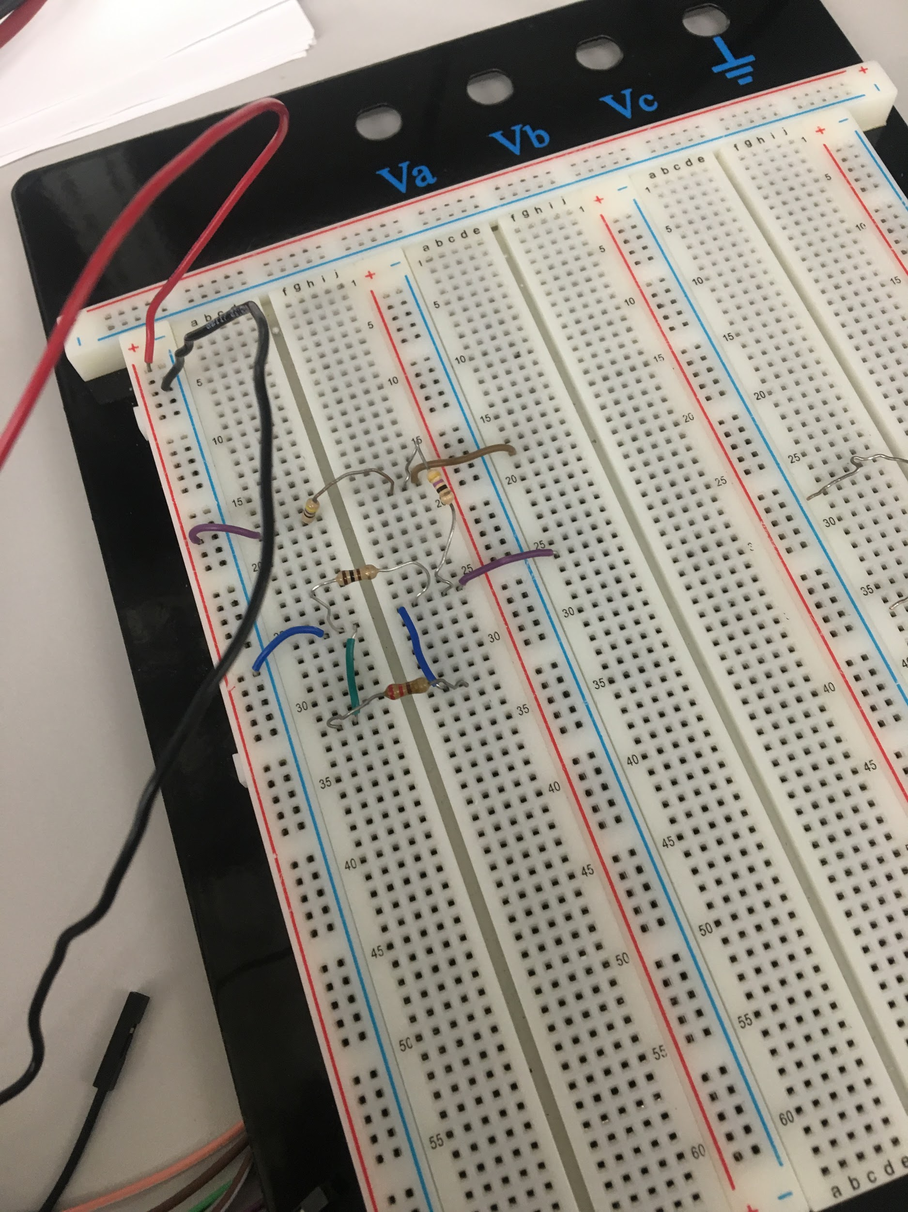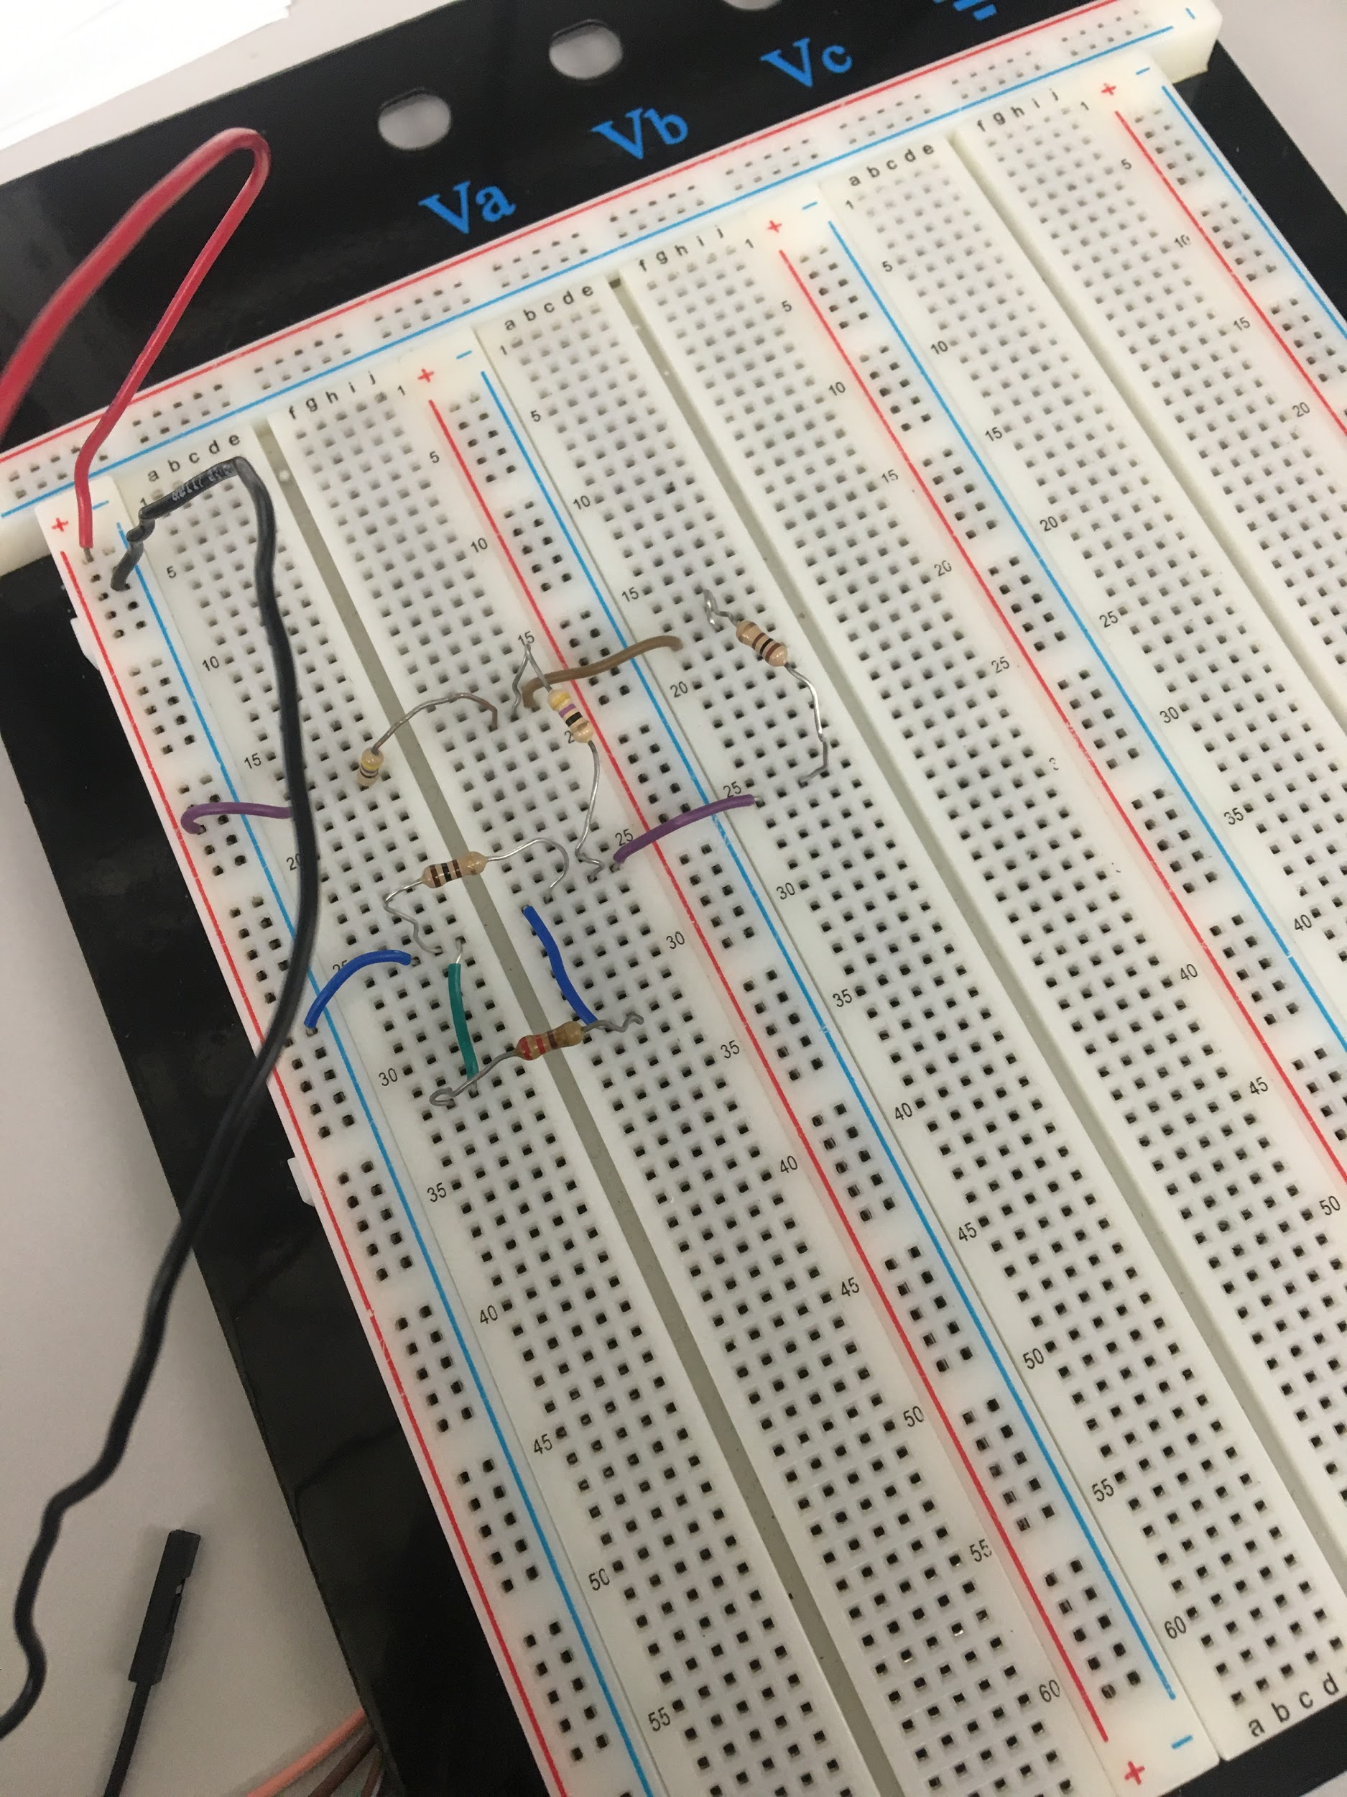

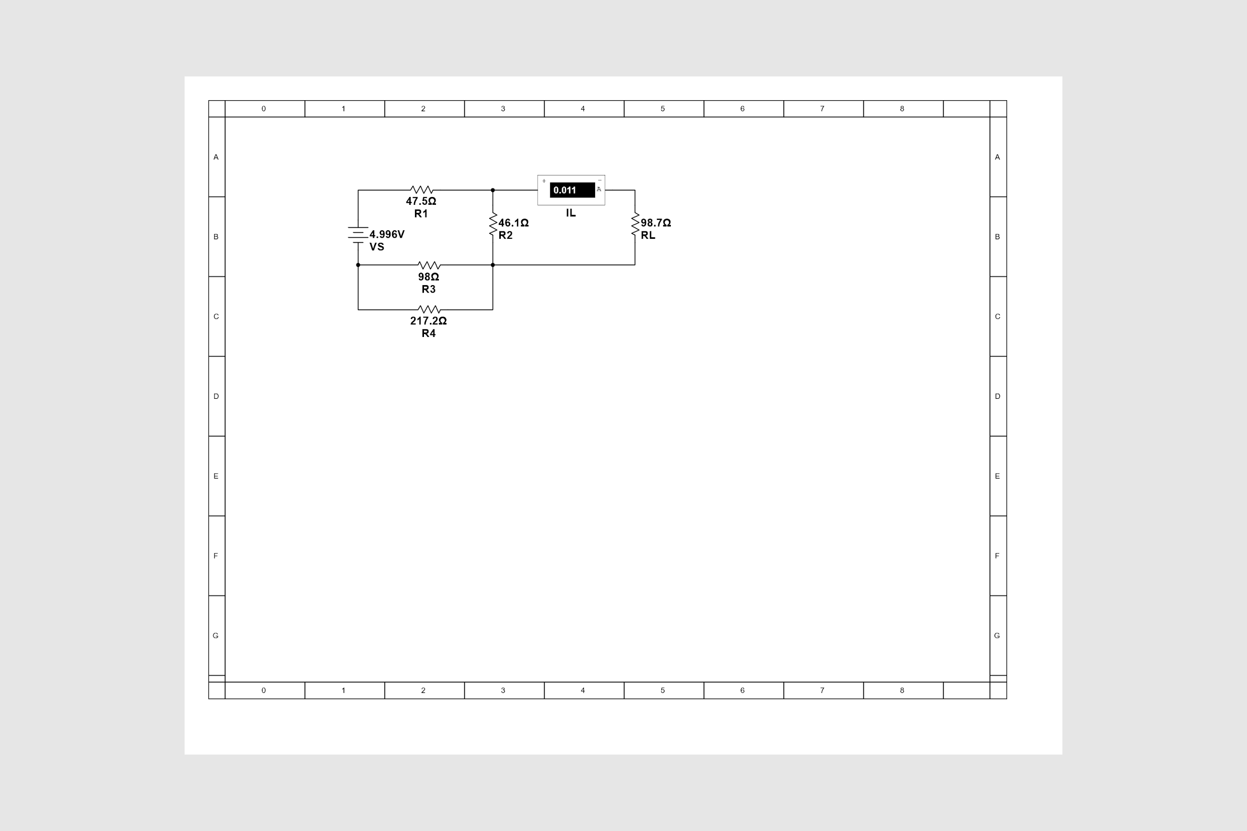

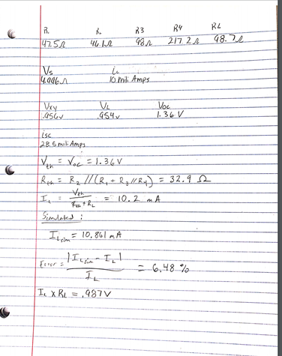

1. **Conclusion**

The experiment shows that calculations and simulations are beneficial in determining the ideal and approximate values for nodal analysis and in creating thevenin equivalent circuits. Physical testing of the circuit, though, allows for values that reflect all the variables found in the real world. Because these methods can approximate and give the ideal values for circuits; they are crucial in their application for the real world, as they can give total acceptable loads and help to determine the direction and magnitudes of the currents in any given part of a circuit.